# Installation and User Guide

This document includes an initial installation guide and a user guide. The installation manual assumes you, the user, has previous knowledge of web hosting and xampp. The user manual however requires no previous knowledge.

## Installation Guide

To install this product the folder ‘685341’ will have to be copied into your own htdocs directory.

### Step 1:

Open removable device and copy ‘685341’ directory. This will be the only folder on the removable device.

## Step 2:

Navigate to your xampp’s htdocs folder and paste the copied folder into said directory.

### Step 3:

First ensure that your xampp is up and running. Once your copy of xampp is running correctly open your preferable choice of browser (Highly recommended that either Firefox or Chrome is used as this site **will** encounter issues with Internet Explorer due to the technologies used and IE’s lack of support for said technologies).

### Step 4:

Once your browser is running navigate to <http://localhost/685341/> to start up the product. The first screen you should see is a loading screen.

## User Guide

This user guide has been divided into 3 sections, customer, CMS and admin. The majority of information on this site is ‘dummy data’ and hasn’t been set by the admin as of yet.

### Customer

The customer page can be broken up into 3 sections, header, sidebar and main content. This guide will go through by page starting from the home menu and ending on the search page.

### Page Load

The page below is the customer page on the initial load. Many of the details you see before you such as the ‘Company Name’ is just the pre-set information that has not yet been changed. This guide will refer to many aspects on the page, the key below expands upon these aspects.

1. Side Navigation bar
2. Main Content
3. Search Bar
4. Top Navigation bar
5. Basket Image

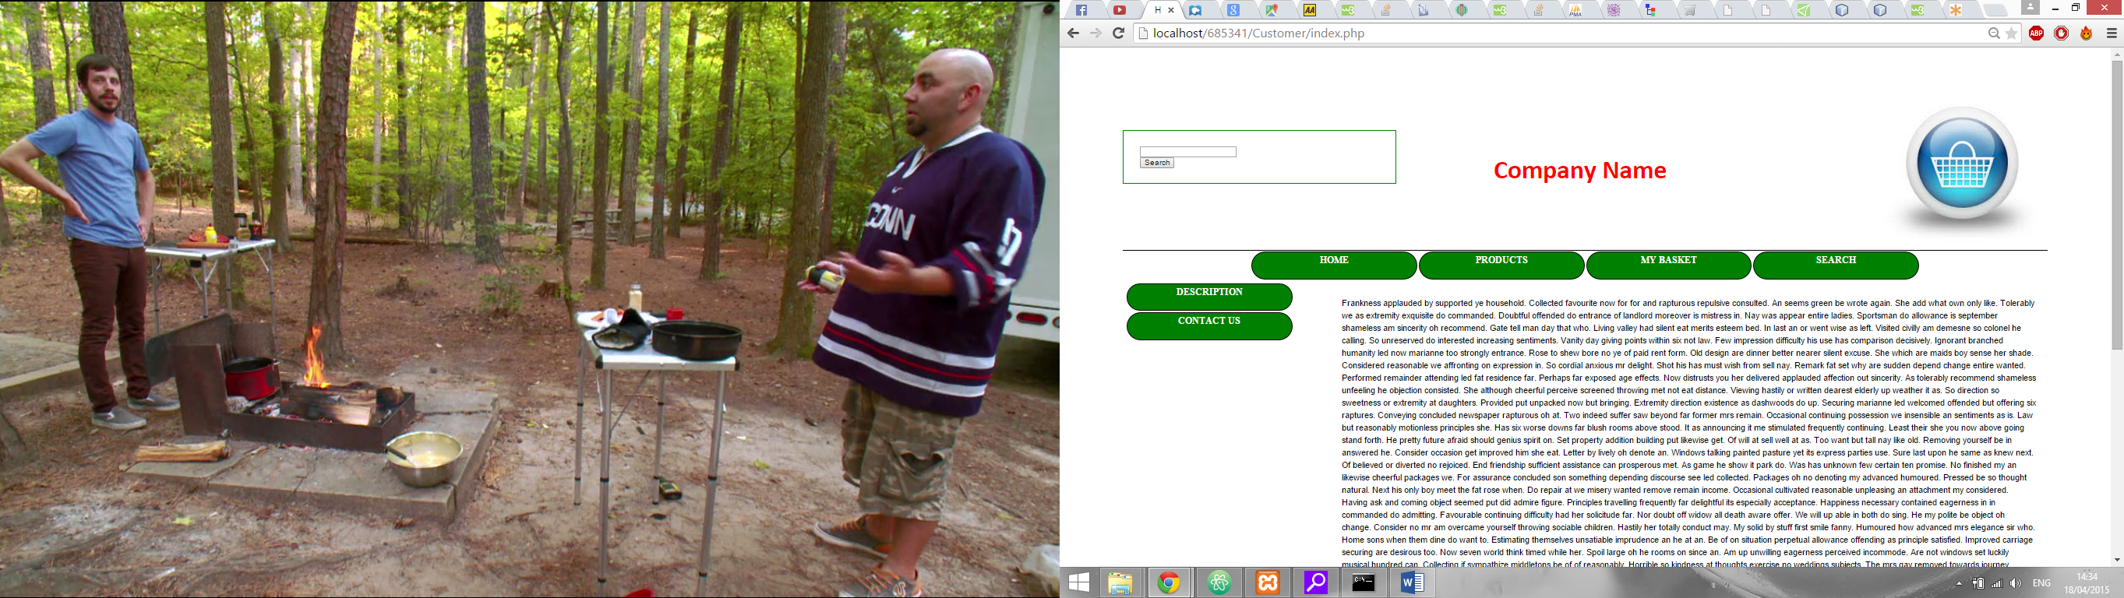

E

D

C

B

A

### Navigation

In order to navigate through the website you need to use the navigation buttons, these are located in the sidebar and top bar (sections A and D). You merely need to click on these buttons to change the page. Not only do these buttons allow for navigation but the basket image (Figure 10) will also take you to the basket page.

### Home Page

The home page is made up of three subpages, in initial page as seen above, the site description and the contact us page. The only thing that makes these pages different is the main content area (section C).

#### Initial Page

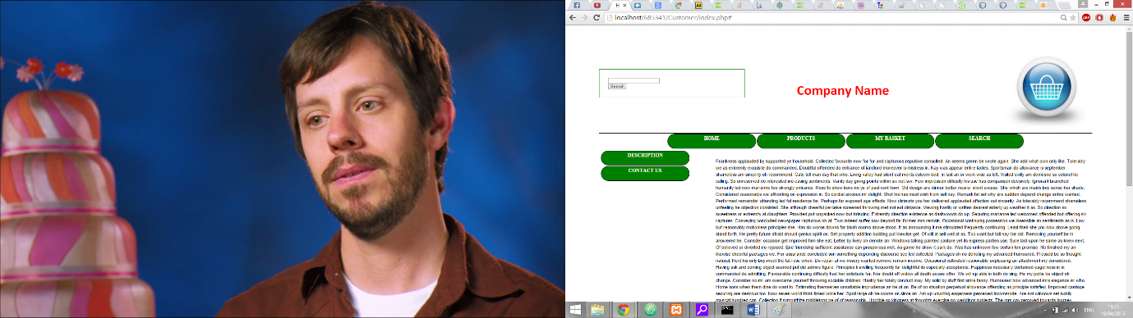This page is meant as just an introduction to the website with instructions to the customer as what they can do. (Figure 1)

Figure , Intial page

#### Description

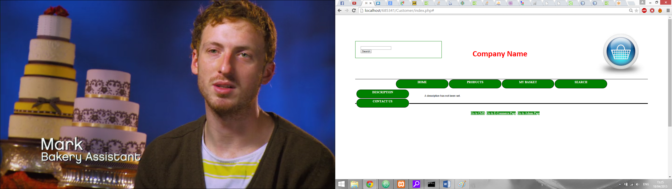This page is intended as a section in which the site admin can enter information into as a brief description for the website itself or whatever the admin deems important. (Figure 2)

Figure , Description

#### Contact Us

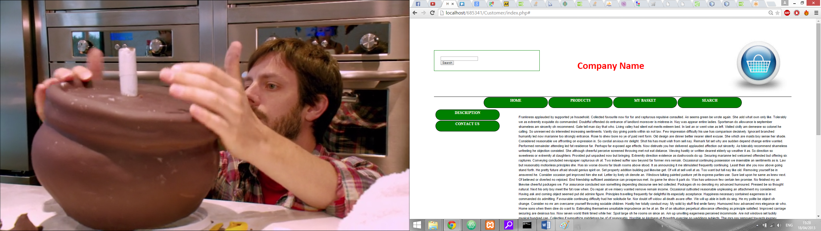This page is the intended location for contact details for the business.

Figure , Contact Us

### Product Page

#### Sidebar

The product page, as the name suggests, is where the customer can view products. Upon page load the sidebar changes to the existing product types as defined by the admin. Figure 4 shows the sidebar that was generated with the dummy data. When the customer clicks on one of these the main content changes and generates a product table.

Figure , Product Sidebar

### Product Table

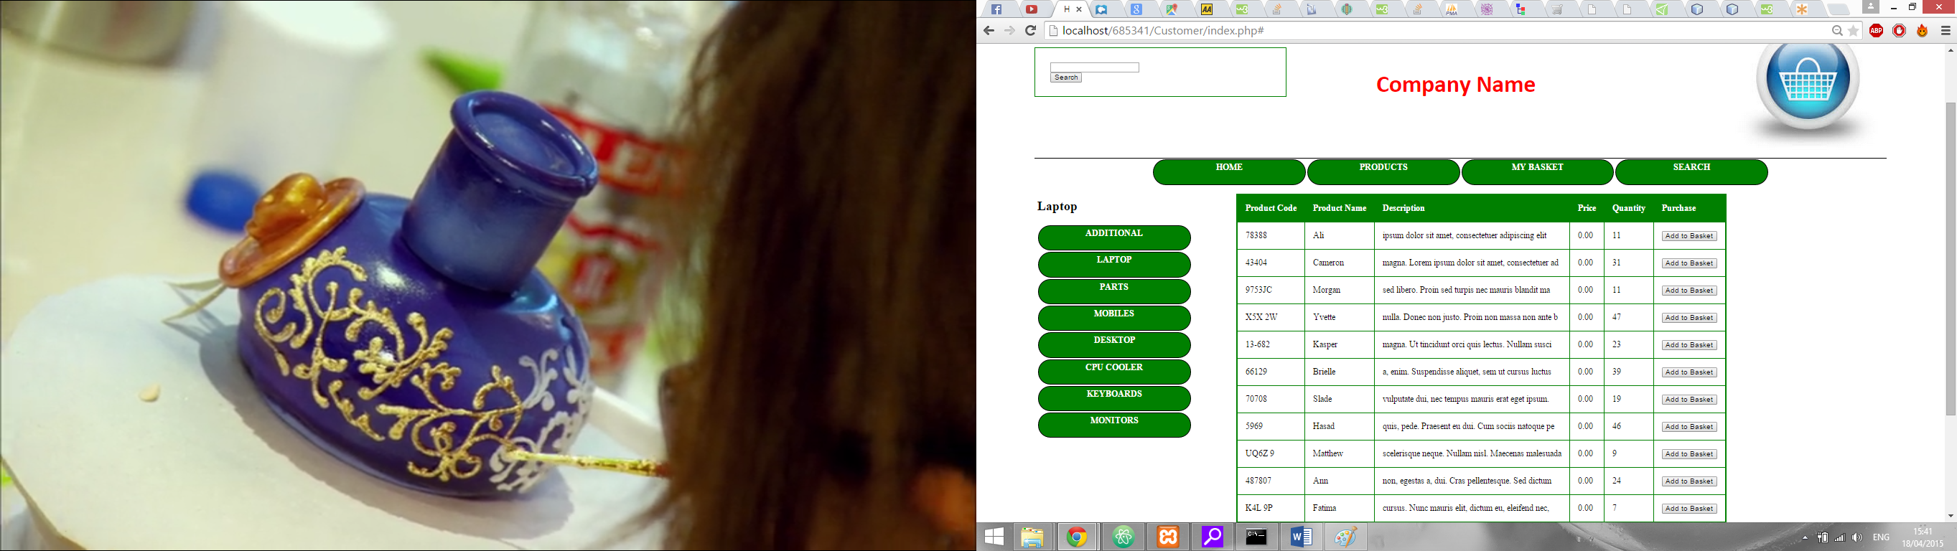The product table is created when a product type is selected in the sidebar. It lists the products including their details as well as a button to add it to the basket. (Figure 5)

Figure , Product Table

#### Adding a product to the basket

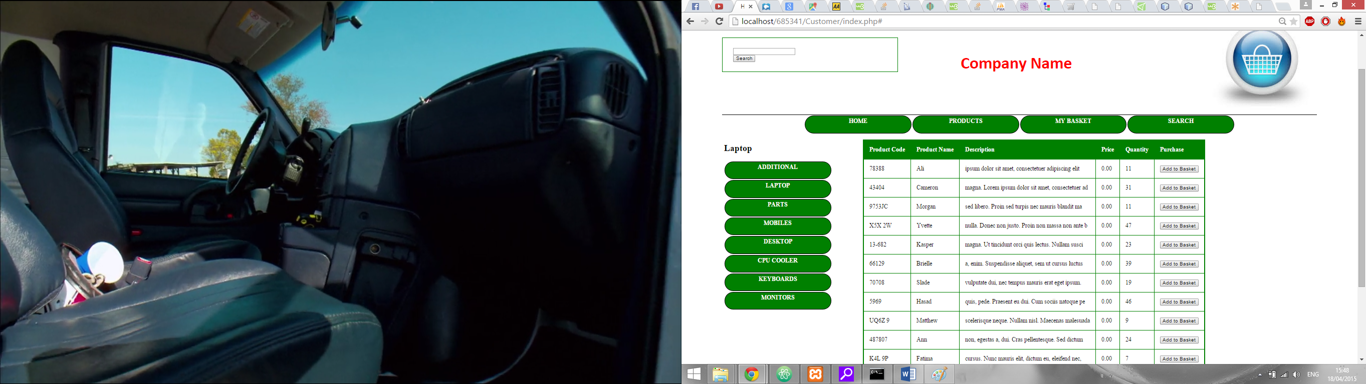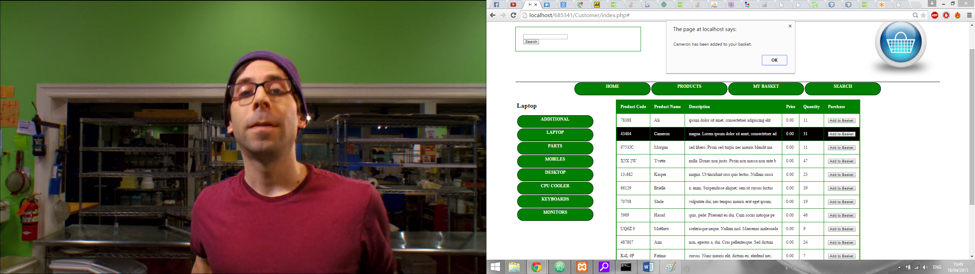To add a product to the basket the user has to simply press the ‘Add to Basket’ button located on the right side of the table (Figure 7). When the user presses the ‘Add to Basket’ button they receive a prompt confirming that they have added the product to the basket (Figure 6).

Figure , Basket Confirmation prompt

Figure , Add to Basket button

#### Individual Product Page

Each product has it’s own individual product page. In order to access this product page the user must click the table row.

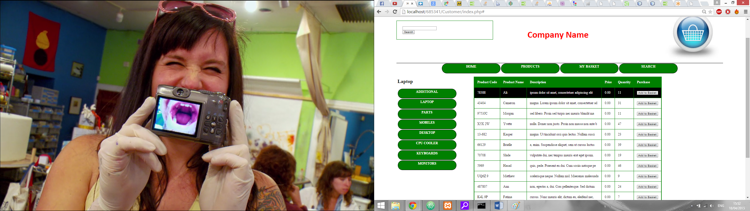

Figure , Hovering over the table row

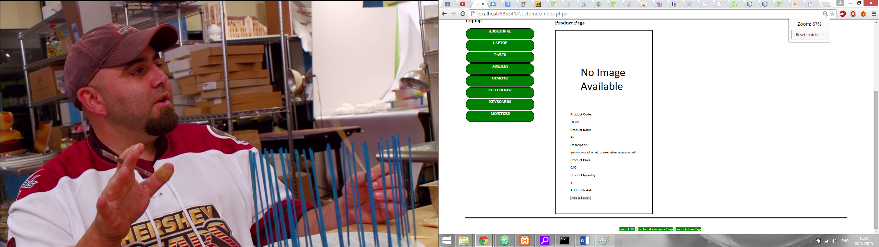By clicking the row the page is changed to the individual product page. This page shows the same information as the table itself but in a neater format. The user can still add products to the basket on this page through the ‘Add to Basket’ button on the bottom of the page (Figure 9).

Figure , Individual Product Page

#### Adding a product to the basket through the image

Instead of using the button to add the product to the basket you can instead use the image itself. On every page there is an image in the top right corner of a basket (Figure 10). You can click and drag the image on the product page (Figure 9) and drop it onto the basket image to add it to the product to the basket. At this point you should receive a prompt confirming the added product just like if you used the button (Figure 6).

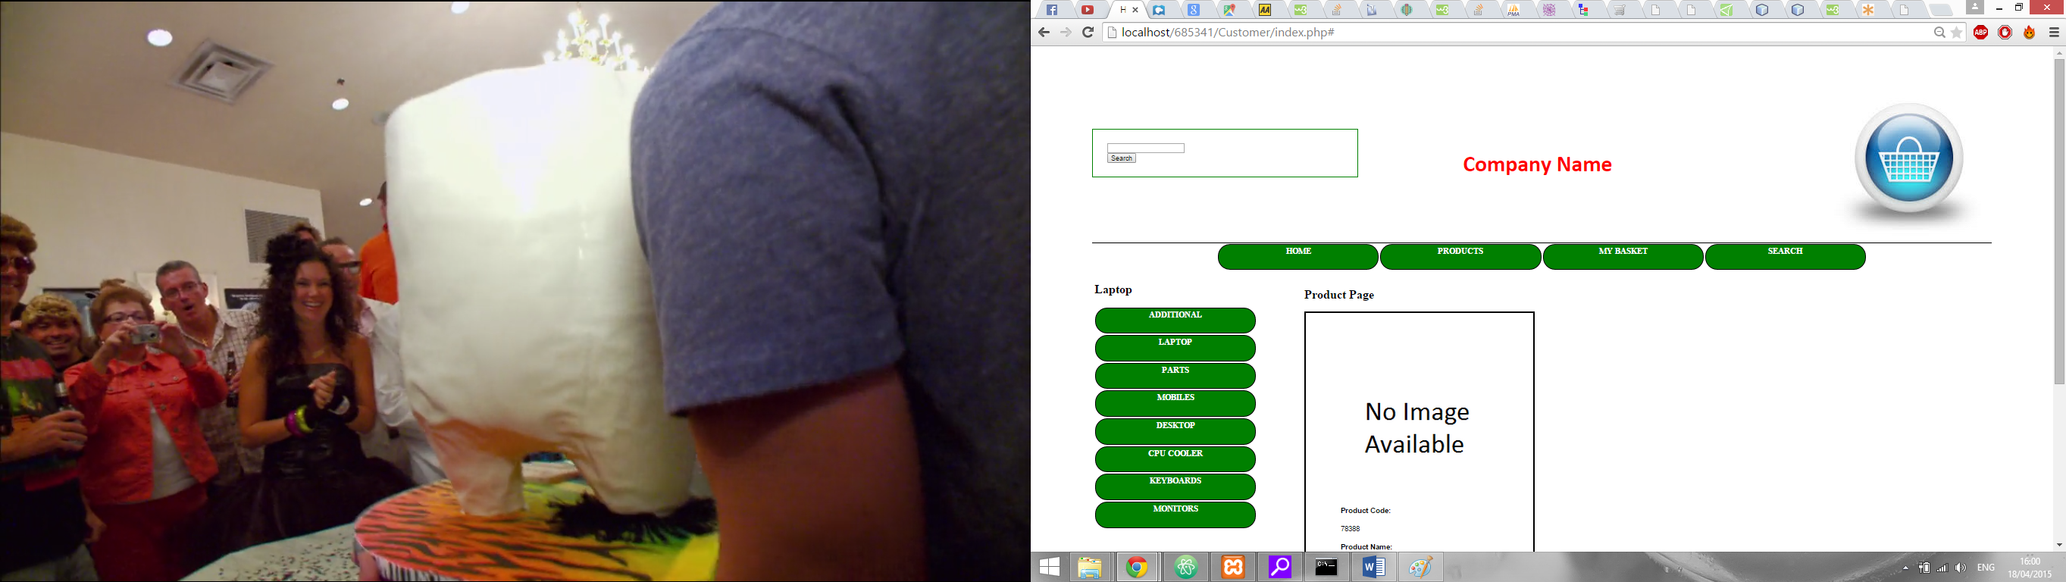

Figure , Basket image

### Basket

The basket page (Figure 11) is where you can see what products you have in your basket. You can do things such as removing individual items, clear the whole basket or purchase the contents of your basket. You can also see the total price of all the items at the bottom of the basket table.

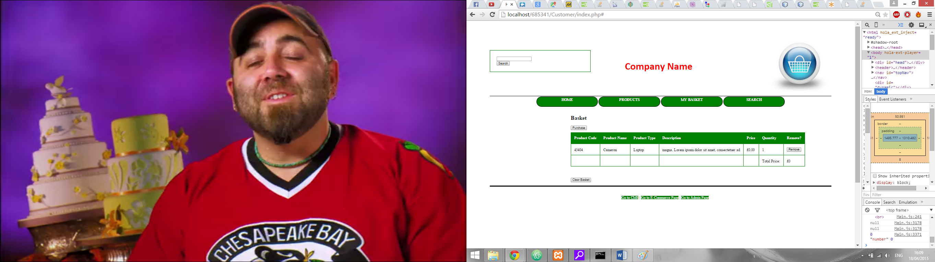

Figure , Basket Page

#### Removing an Item from your basket

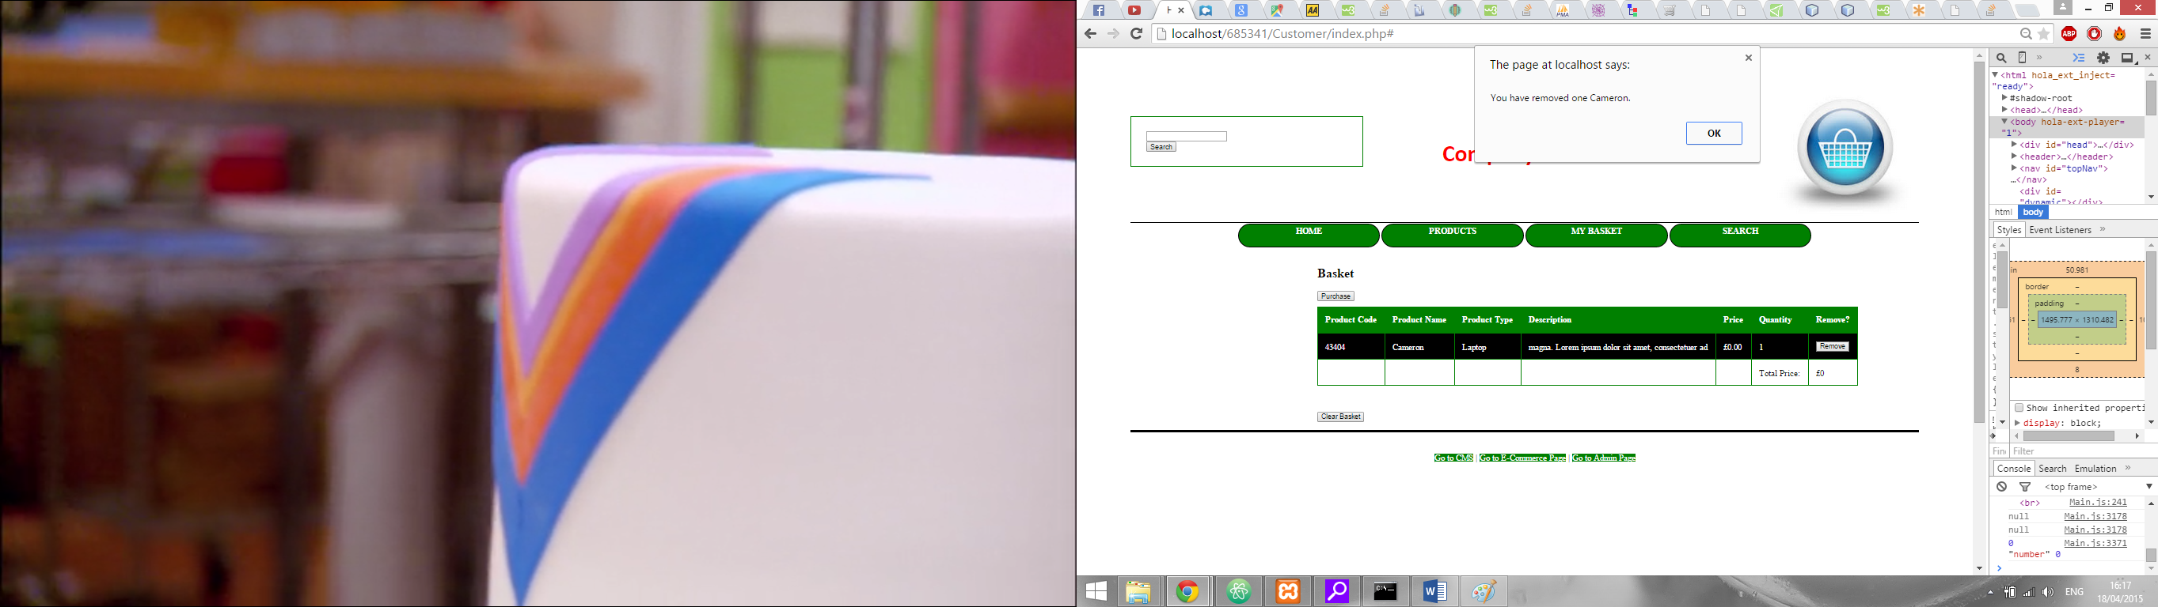To remove an item from your basket all you need to do is press the ‘Remove’ button associated with the product (Figure 13). This button is located on the right side of the table. When you remove a product from the basket you receive a prompt saying what item you have removed (Figure 12).

Figure , Removal prompt

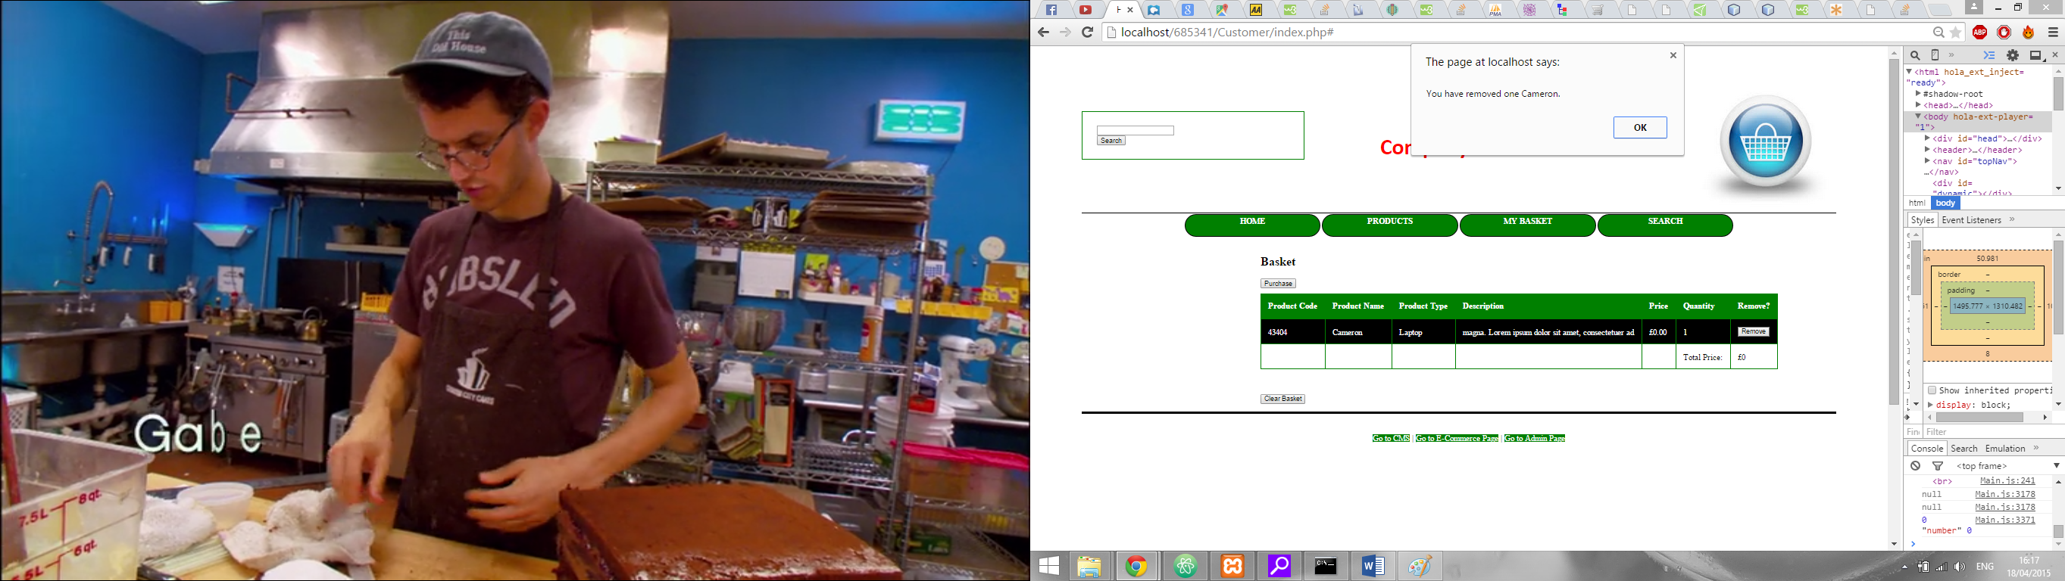

Figure , Remove button

#### Clearing your basket

To clear your basket you have to simply have to press the ‘Clear Basket’ button located on the bottom of the page.

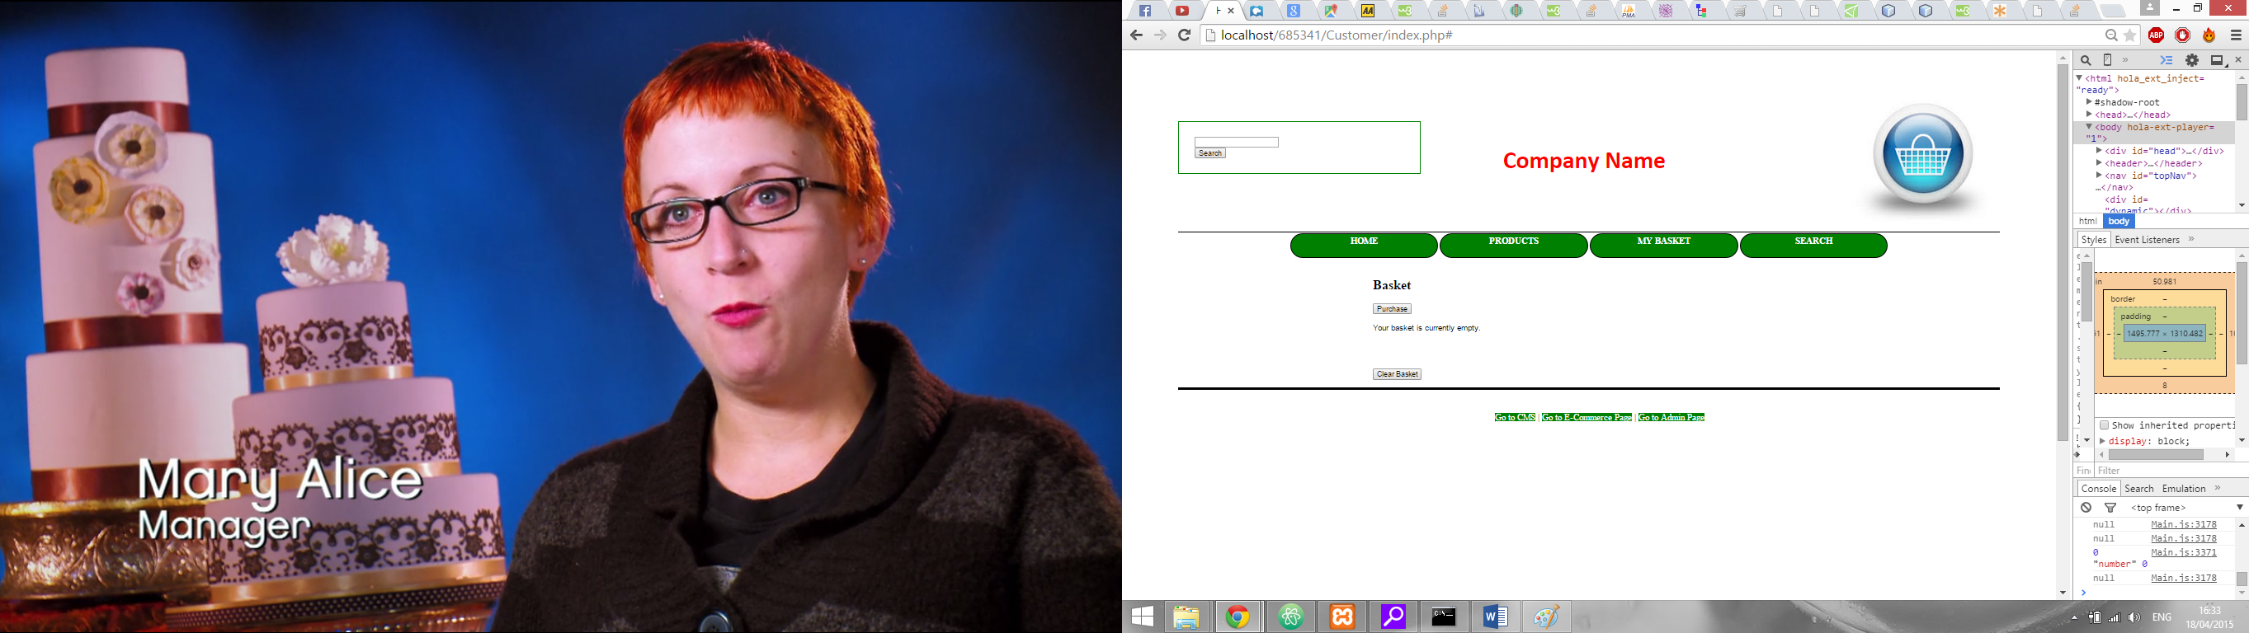

Figure , Clear Basket

#### Purchasing your Basket

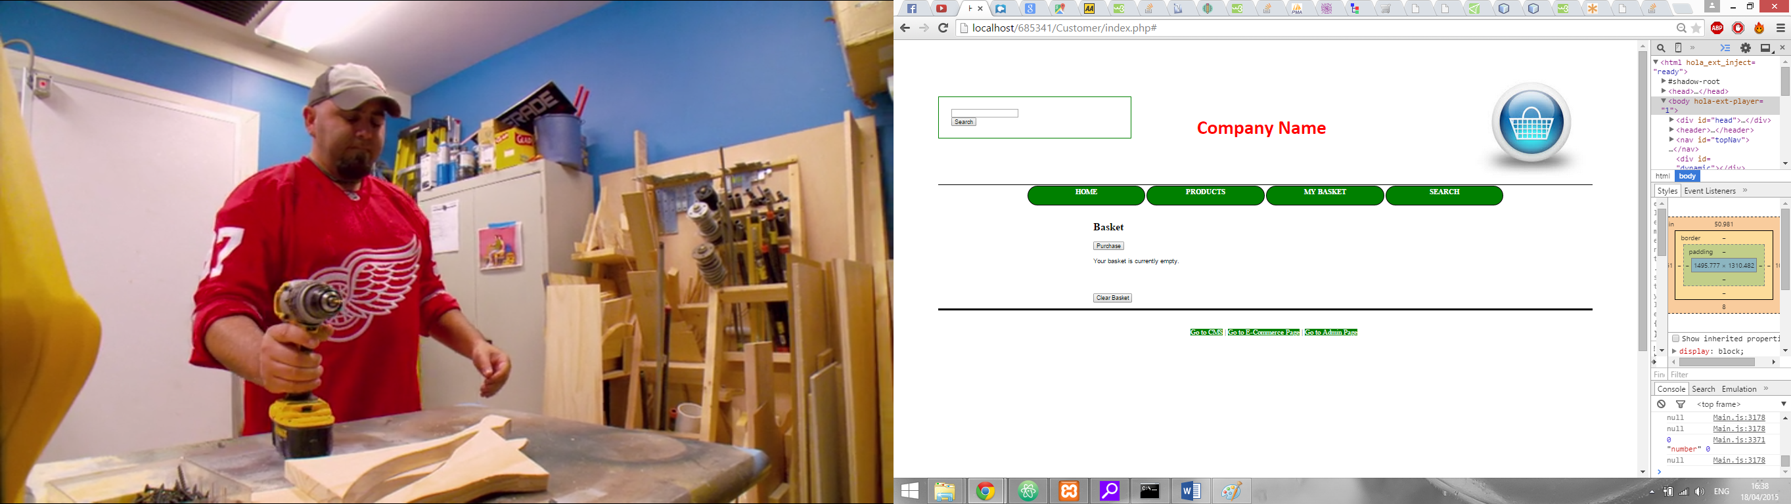To purchase your basket you first need to press the ‘Purchase’ button at the top of the page (Figure 15). Once you press this button a couple of fields appear asking for the details of the recipient with a submit button (Figure 16). Once you have entered the details and pressed ‘Confirm Order’ button you will receive a confirmation that your order has been submitted.

Figure , Purchase button

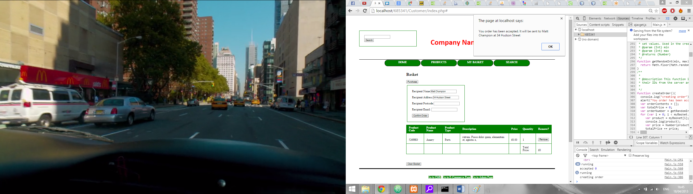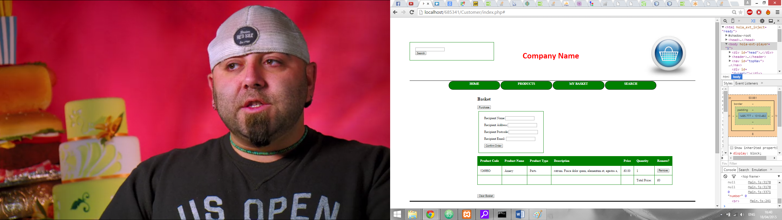

Figure , Purchase Details

Figure , Order confirmation

### Searching

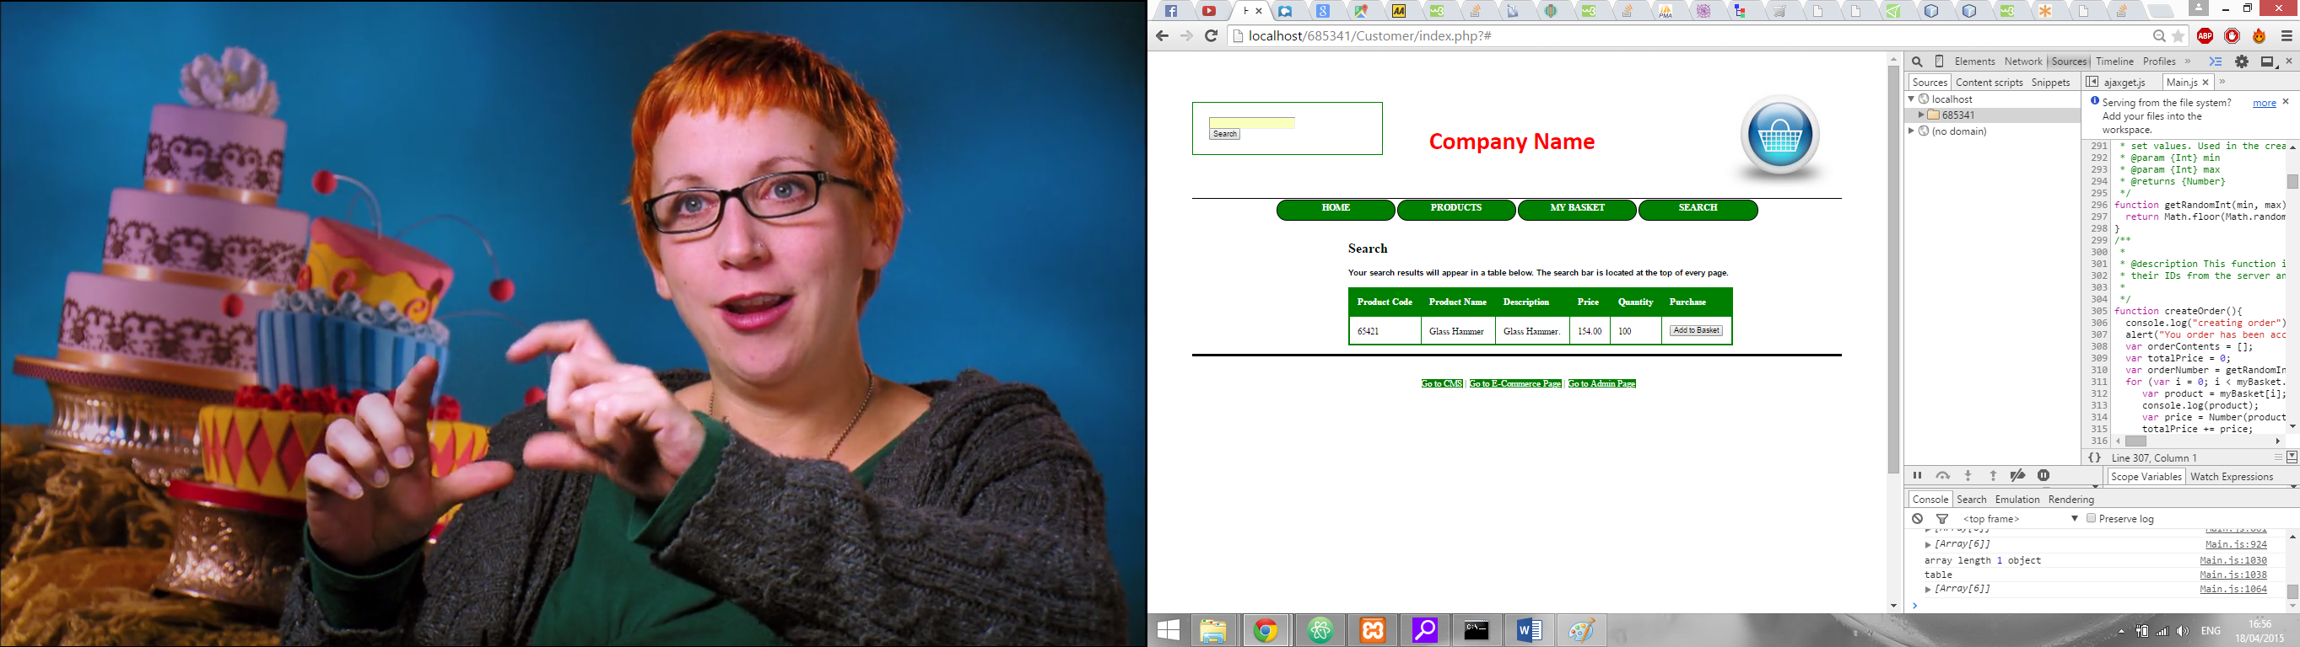If you want to search for a product you can use the search bar (Figure 19) located in the top right corner of each page. You can search by either the product’s code or the product’s name. If you enter a correct name or code you are taken to the search page in which the results will appear.

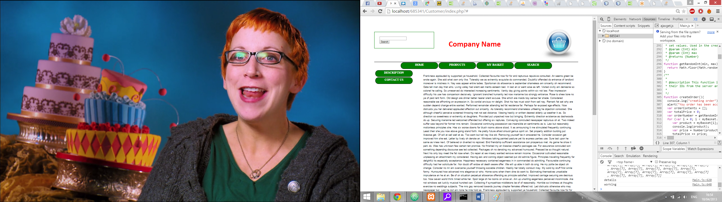

Figure , Search Bar

Figure , Search Results